

Perfect Parking A map API parking application: A Literature Review from a Technological Perspective

Rhys Quilter: K00241356 | Final Year Project | 14/10/2022

Table of Contents

1.0 Abstract 2

2.0 Introduction 2

3.0 Application Programming Interface (Api) 4

What Is An API? 4

The History Of API’s 4

What Is A Mapping API. 5

What Is Directions API 5

How Can I Use Directions API 5

4.0 Big Data And Realtime Data 6

What Is Big Data 6

Why Is Big Data Important 6

What Is Real Time Data 7

What Is The Importance Of Real Time Data 7

The Problems I Face With Gathering Data 8

5.0 Web Service Frameworks 8

Java Spring Framework 9

Why Use Java Spring. 9

Advantages And Disadvantages Of Spring Framework 10

Conclusion 11

C# Asp.Net 12

Why Use Asp.Net 12

Main Advantages Of Asp.Net 13

Conclusion 13

6.0 Problem Statement 14

7.0 Review Description 15

8.0 Conclusion 17

References 18

# Abstract

This project is a Parking application for academic purpose. The aim of my project is to create a parking system that will replace the outdated systems and to help stop the widespread problem that is parking in our cities. The applications that are used in Limerick City are simply not good enough. So, the goal in this project is to improve the effectiveness of finding parking spaces and to also relieve the stress of the users looking for parking by implementing new and innovative features. I will do this by using Django framework structure and by implementing methods such map API’s that will show the user exactly where the parking is and by providing locations for them to follow straight to the location. I will also use a parking monitor powered by OpenCV to detect if a parking spot has been filled or made empty. By doing this I feel like it will also help with traffic congestion in the city as people won’t need to keep driving around the block to find a convenient parking space.

# Introduction

Due to an increase in in the number of cars being used in limerick city and other cities in Ireland, finding a solution to car parks has now become vital. The old-fashioned way of parking was that everyone would just leave their cars parked in the streets until they were needed again, this however caused major traffic congestions in towns and cities. Shop owners also got hugely impacted as there wouldn’t be enough room for staff to park no mind the customers looking to go into their shops which was damaging for their business, it is undeniable that car parks are a very important factor in society, by having parking spaces it reduces illegal parking which would have increased congestions on the road and increasing travel time.

It is fair to say that parking back in the 1980s – 1990s wasn’t such a big issue as there wasn’t very many cars on the road as people couldn’t afford to have a car unless they were wealthy, nowadays however it is very hard to find available parking spaces in places such as cities, and of course universities especially during rush hour. Since limerick City is a big city for students to come and study in with there being over 16,000 students attending university of limerick and just under 2000 students in TUS and Mary I, this brings so much more motor vehicles into limerick city which is a city already struggling with car parking. (UL.ie, 2022)

My goal is to try and reduce this issue by building a new innovative parking app and to try to help motorists stop stressing about this parking crisis.

## Application Programming Interface (API)

### What is an API?

An API are a mechanism that allow two software components to communicate with each other using different definitions and protocols. An example of an API would be the bureaus software system which contains the daily weather data, the weather app on your phone would talk to this system using APIs and shows you the daily weather updates on your phone. (What is an API, 2022).

### The History of APIs

Between the years of 2000 and 2002, online commerce and information sharing was just starting to become huge. Companies began to see an opportunity to expand their impact by making their information more accessible and shareable than ever before, these companies being Amazon, eBay, and Salesforce.

In the year 2000 Salesforce finalized and released their first modern API. Within this time eBay and alongside them Amazon also developed their own API which allowed developers access. What this meant was that for the first-time data-sharing was openly accessible for a wide range of customizable uses.

As the years went on many companies started to explore APIs, as this went on the APIs began to grow and software companies realized that APIs were a convenient way to share resources with their developers and to expand their footprint, spark ideas and to accelerate their development.

One of these software companies was Google, with their Google Maps. Google launched its API in 2006 they done this to share the massive amounts of geographical data that they have collected. This being the Google Maps that we know today, being Google Street View, and the Map application on our mobile phone which we use for navigation. (Hawkins, 2020)

### What is a mapping API.

A map API also known as mapping API provides location intelligence for software developers that are developing location-based products or services. It is the base building blocks for location-aware infographics.

A typical Map API have features including geocoding, reverse geocoding, geolocation, directions, and navigation. There are other features such as different types of maps such as terrain or satellite.

Map APIs are a great way for developers to retrieve location data such as proximity details about places, travelling distances and the time it will take between different endpoints. We saw map APIs being used in the pandemic to identify areas that had big spikes in covid cases which would be marked in red on the Covid app. (What is a Mapping API, n.d.)

### What is Directions API

Directions API is a geolocation service that software developers can use to plot routes between different places on a map. The Directions API make it easier for developers to create interactive location-based applications. (Google Maps Platform, n.d.)

### How can I use Directions API

Directions API can play a big part in my application, the reason that I am saying this is because if road users are new or visiting the city and they would need to figure out how to get to this parking lot. Using google Directions API would be a great way of doing this, when the user finds a parking lot, they would like to use they would simply press the parking icon and they would get a prompt to get the directions to the parking and when clicking this it would open up there google maps and show them the fastest way of getting to their location and the time it will take. This will eliminate the road users worry from getting from their location to the parking lot.

## Web Service Frameworks

When I decided to create a web application, I started to do some research on different web Service frameworks to decide what framework I feel would work the best for my application, the frameworks that I carried out research on were:

* Java Spring
* C# asp.NET

### Java Spring Framework

The Spring framework is a great application framework and inversion of control container for the Java platform. It is a great example of high-quality software. Spring provides everything required beyond the java programming language for creating enterprise applications for a wide range of scenarios and architectures. It has been developed for over 17 years (George, 2021).

#### Why use Java Spring.

Spring framework helps develop various types of applications using the Java platforms. It provides an extensive level of infrastructure support. Spring also provides the Plain Old Java Objects also known as POJOs mechanisms which developers can easily create the Java SE programming model with the full and partial JAVA EE.

Spring Strives to facilitate the complex and unmanageable enterprise Java application development revolution by offering a framework that incorporates technologies, such as:

* Aspect-oriented Programming
* Dependency Injection
* Plain Old Java Object

The Spring framework also provides plenty of features. It helps the developers to perform the following functions.

* Create a Java method that runs in a database transaction with no help from transaction APIs.
* Create a local Java method that defines a remote procedure with no help from remote APIs.
* Create a local Java method for a management operation with no help from JMX APIs.
* Create a local Java method for a message handler with no help from LMS APIs

(Simplilearn, 2022)

#### Advantages and Disadvantages of Spring Framework

Java spring consists of multiple tools to get numerous web app development benefits. When using spring it allows us to not write lengthy code. It is beneficial because it saves developers time and energy. I will now discuss the advantages and disadvantages of the Java Spring framework.

**Advantages**

* **Flexibility:** it offers flexible libraries to assist developers. Users can choose between XML and Java-based annotations regarding configuration. IoC and DI features are also present to provide extensive functionality and features.
* **Consistent configuration:** It helps in providing a consistent way of configuration. It offers a separate configuration for the facilitation of developers.
* **Secure:** the framework offers frequent updates to make our data an apps more secure.
* **Simpler testing:** Developers can perform testing with ease due to this framework. It is possible die to the usage of dependency injection.

**Disadvantages**

* **Complexity:** it is complex to work with Spring. Developers must have more relevant skills and expertise to use this framework.
* **Hard to learn:** if you have little or no experience regarding development, it will be difficult to learn Spring. This is due to the incorporation of the latest programming techniques in this framework.
* **Uses XML:**  lots of XML is needed while developing a Spring app. It can also be problematic for developers.
* **Parallel mechanism:** while using Spring developers can get multiple options. It can be very helpful in some cases, but it can also be confusing. Developers can run into problems when it comes to selecting the right mechanism and can result in wrong decision making. If these mistakes are made it can cause delays in the development of the applications. (Bashir, n.d.).

#### Conclusion

From the research that I undertook on the Java Spring Framework it stands as a strong contender for a framework that I will possibly use, I also have experience in this framework which will also be a huge help when it comes to the design stage of the project.

### C# ASP.net

ASP.NET is an open-sourced web framework for building web applications. It is created by Microsoft, version 1.0 was released in 2002 to allow developers to build dynamic web apps. Services and sites. The framework is built to work with the standard HTTP protocol, which is the standard protocol used across all web applications. (Tyler, 2022)

#### Why use ASP.NET

There are many reasons why developers should choose to use ASP.NET when developing a website or application. High speed, low cos, and vast language support are among the most significant benefits. ASP.NET is built into the familiar Windows server environment, requiring less setup and configuration than other web development platforms that must be installed and configured separately. The popularity of ASP.NET makes online resources and skilled developers easy to find.

Applications built using ASP.NET can be faster and more efficient than a website that is built using PHP, for example ASP.NET applications are compiled, which means the code is translated into object code, which is then executed. This compilation process takes a small amount of time but happens only once. After compilation, the code can be executed repeatedly by the .NET platform very quickly.

The database type that you would like to use is an important decision that has to be made when developing a web application, when using ASP.NET you have a choice of different databases such as Microsoft SQL server, MySQL, MariaDB to name a few. However MySQL and MariaDB are free and open source but Microsoft SQL Server can require expensive software licenses, there is a free express version which is suitable for a majority of websites.

ASP.NET is written using OOP also known as Object Oriented Programming languages such as C#. OOP provides a framework and patterns for code organization and reuse. C# is a first-class programming language and consistently ranks among the world’s most in demand and most use programming languages.

ASP.NET is developed by the world’s largest software company, Microsoft. Microsoft is heavily invested in their development platforms. Their development community and supporting the software companies use to run these applications. What this means is that there is no need for you to worry about your software becoming obsolete any time soon. (Wiseley, 2018)

#### Main advantages of ASP.NET

* The ASP.NET is a web framework is facilitated by a powerful toolkit and designer in the integrated development environment of visual studio. The Drag and Drop sever controls and auto deployment are only a couple of the features this versatile tool offers.
* Lesser code encourages the application to easily manage and effectively maintain.
* These applications have windows authentication which makes the applications more secure.
* In ASP.NET applications, source code and HTML files are together so ASP.NET pages are easy to manage and write. The source code is now being run on the computer. This gives the website a lot od strength and versatility.
* ASP.NET helps in developing robust web applications7

(geeksforgeeks.org, 2021)

#### Conclusion

From the research that I undertook for ASP.NET I learned that this framework is very dominant over other frameworks such as the Java Spring. I feel like ASP.NET would be a great framework for building prototype screens for my application because of the drag and drop feature that ASP.NET has within the Visual Studio IDE. This gives me a lot to think about in terms of what framework I should use for developing my application since I have researched two really good frameworks.

## Problem Statement

**Ineffective ways of finding an available parking space which is a waste of time, very fuel consuming and causes traffic jams.**

when road users are looking to find an available parking space they end up wasting time and using a lot of fuel from them driving around the car park or the block multiple times hopping to find a space, on average people spend 17 hours per year driving around looking for parking spaces (Quellmalz, 2021). By developing my app Perfect Parking I’m hoping to make the parking process in college campus and in the city easy and stress free, by doing this I’m hoping to eliminate the time and fuel waste road users encounter while looking for parking.

**Lack of visual parking space availability.**

When road users are driving the visuals of the eye are limited, the vision is blocked by many obstacles such as the cars frame causing blind spots, other cars, trees and much more. With this in mind it can be understood that the road users can find it difficult to spot an available parking space if its in the distance or behind other cars. This has turned into an important problem with road users and as a result they waist time and fuel trying to spot an available space.

**Lack of knowledge of towns or cities.**

Limerick is a city where people migrate to for education or tourism, and with this brings more road users. When people first come to Limerick City, they have to learn the road routes and with this where the parking is. A lot of road users that drive in a new place start to panic and get anxious when they try and find parking. This can cause them to be in the wrong lanes and cause traffic congestion. But with my app it will allow users to plan their route to the parking of their choice and follow directions on the phone to the car park. By doing this that it will keep new road users in the city calm so they can enjoy there holiday or for students teach them the road routes and the best places to park.

## Review Description

From doing research into parking systems, I have realized that there is a lot of existing parking systems that use different strategies and approaches to reach their goals and solve the problems of parking systems.

In this section I will review a few systems that I feel are unique and that have good strengths but that also have some weaknesses.

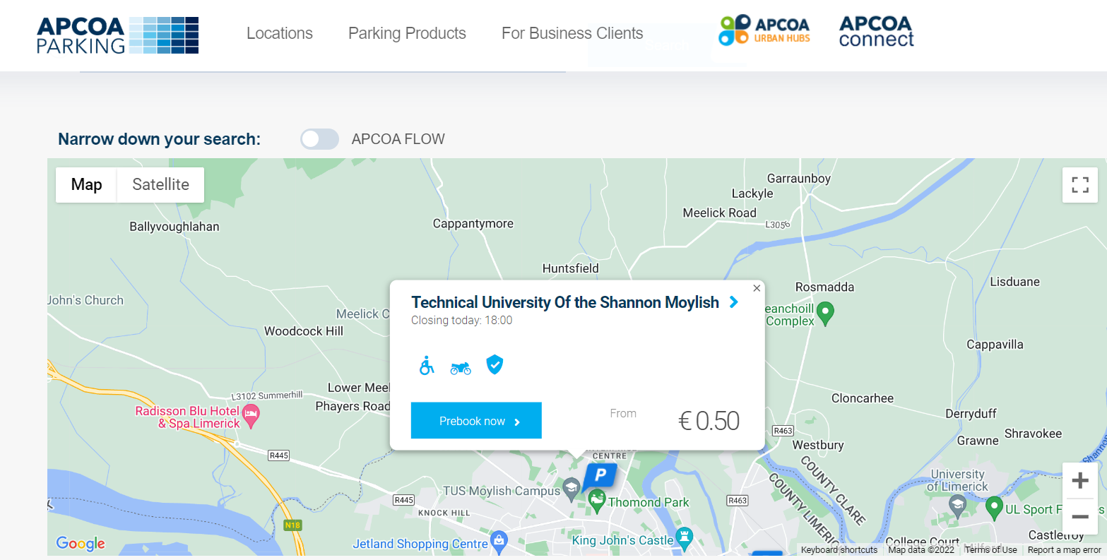

*Figure 1.0: web parking application to find parking in your area* (APCOA, 2022)

**Brief**

APCOA is a parking application that supports Android mobile, iPhone, and windows OS. APCOA is smart parking application, we use this company in our TUS Moylish campus as of today. The application is very user friendly it allows the user to see how much the parking is per hour and as seen in figure 1.0 above shows in blue there is parking facilities available to cater for disability parking, motor bikes and that the location is secure and safe to park in with controlled gates and surveillance cameras. This changes for different locations that you’re looking to park in. In this application it allows multiple ways to pay, you can prepay by using your debit or credit card, if you’re on Android or IOS you can pay using Google Pay or Apple Pay respectfully. There are also options to pay in cash when you arrive. APCOA claim that they can help you find and pay for parking in seconds.

**Strengths**

From looking at figure 1.0 above we can see that the application uses a Google Map API to equip the user with a map so they can see the exact location of the car park that they would wish to book. With them also showing the parking facilities in the car park this can allow users to plan which car park they can park in depending on if they need disabled parking or motorbike parking and so on.

**Weaknesses**

one of the weaknesses of this application is that it doesn’t show the user if there is parking available in that certain carpark, what this means is that if a user does pre book their parking they are not guaranteed a parking spot on their arrival. This could lead to the user being frustrated on arrival.

**Recommendations**

The limitation mentioned above can be sorted by developing a simple interface that will reduce the number of spaces available when somebody pre books on the app or pays on arrival, by doing this it will limit the number of frustrated users. Another recommendation that I will make about this application would be that the user could get the location of the parking lot and use their Apple or Google maps to take them to that location.

# Conclusion

Since starting my FYP on Perfect Parking and the research that I have undertaken I have learned how important Data and real-time data is, without using this data the application wouldn’t be as user-friendly and would lack information that the users would find useful. Real-time data isn’t the be all and end all of my application, I must be realistic to myself and I know its not possible to create a full-blown scale parking application by myself and have loads of data with loads of information. However, I can try my best by using tools such as Google APIs to supply information for example estimated times of arrivals for user and traffic data. When it comes to building a sensor, it is a brilliant idea but when I weighed up the pros and cons of building the parking sensor there was more disadvantages than advantages as described in heading 4.0 paragraph 4.4 .

In above passages I have discussed and investigated how important parking is in road users’ lives. By building the Perfect Parking application it will make road users lives easier and stress free when it comes to looking for parking. By developing this app, I am also hoping that it will reduce the carbon emissions as it will prevent road users from driving around a car park or city in the hopes of finding a parking spot.

From investigating the issues and importance of parking and how building an application can benefit road users who struggle to find parking, this has allowed me to investigate the most ethical way of continuing with the project from a technological and personal perspective.

I have also learned a lot about two different frameworks these being Java Spring and ASP.NET, this leaves me with a very important decision on which framework I will choose to use as they both have great valuable aspects however, from my research there are also some negatives that will weigh my decision.

# Analysis and Design

## Unique Selling Point

Parking is an issue that contributes to traffic congestion especially in cities. Cars driving around and around a city for parking adds to the traffic. Cars hovering for parking spots or cars double parked can cause traffic to stop. The purpose of perfect parking is to try and solve the common problem of traffic congestion and scarcity of parking in a city such as Limerick. Perfect parking aims to ease the stress and anxiety that road users face searching for parking by providing live data about availability, pricing, stay-hours, zones, and disability status. Additional benefits include reducing traffic congestion, fuel savings, time and reduces stress.

## The Application

Perfect Parking is a web application that will allow users to find parking in a city. The application will allow users to search for parking near a specific location, and will show the user data the nearest parking to their location.

## Users Use Case Diagram

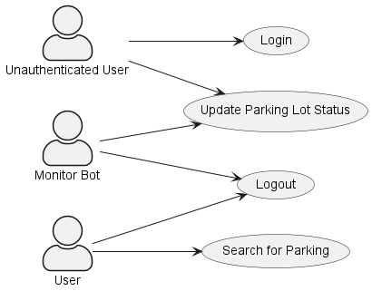

Alt text

## System Actors

* Administrator: The administrator is responsible for managing the application. The administrator can add new parking locations to the database, and can also remove parking locations from the database.
* User: The user is the person who will be using the application. The user can search for parking near a specific location.
* Guest: The guest is a person who is not logged in to the application. The guest can only search for parking near a specific location.
* Monitor Bot: A monitor is a bot that will be monitoring a car park. The monitor will be updating the status of the car park.

## Use Case Descriptions

### Use Case: Find Parking

**Description:**

A user searches for parking near a specific location.

**Actors:**

* User

**Trigger Event:**

* A user wants to find parking near a specific location.

**Preconditions:**

* The user is logged in to the application.
* The website has permission to access the user’s GPS location.

**Post conditions:**

* The user is shown a list of parking locations near the location they searched for.

**Main Flow:**

1. The user details the location they want to find parking near by:
   * by searching for a specific address in the search bar.
   * by clicking on a location on the map.
   * by clicking on a location on the list of parking locations.
   * using the current location of the user.
2. The application shows the user a list of parking locations near the location they searched for.

**Alternative Flows:**

* If the user does not have permission to access their GPS location, the user can search for a specific address in the search bar.

### Use Case: Register User

**Description:**

A user registers for an account on the application.

**Actors:**

* Guest user

**Trigger Event:**

* A guest user wants to register for an account on the application.

**Preconditions:**

* The guest user is not logged in to the application.
* The guest user has not registered for an account on the application.
* The guest has a valid email address.

**Post conditions:**

* A user account is created for the guest user.

**Main Flow:**

1. The guest user clicks on the “Register” button.
2. The guest user enters their details into the registration form.
3. The guest user clicks on the “Register” button.
4. The application creates a user account for the guest user.
5. The guest logs in to the application.

**Alternative Flows:**

* If the guest user enters an email address that is already registered to an account, the application will display an error message.

**Use Case: Login User:**

**Description:**

A user logs in to the application.

**Actors:**

* User

**Trigger Event:**

* A user wants to log in to the application.

**Preconditions:**

* The user is not logged in to the application.

**Post conditions:**

* The user is logged in to the application.

**Main Flow:**

1. The user clicks on the “Login” button.
2. The user enters their details into the login form.
3. The user clicks on the “Login” button.
4. The application logs the user in to the application.

**Alternative Flows:**

* If the user enters an incorrect username and password, the application will display an error message.
* If the user enters an username that is not registered to an account, the application will display an error message.
* If the user account is disabled, the application will display an error message.

### Use Case: Update Parking Lot Status

**Description:**

A monitor bot automatically updates the status of a parking lot.

**Actors:**

* Monitor

**Trigger Event:**

* A monitor updates the status of a parking lot.

**Preconditions:**

* The website application is running.
* The monitor is connected to the internet.
* The monitor has a valid API access token.

**Post conditions:**

* The status of the parking lot is updated.

**Main Flow:**

1. The monitor sends a PUT request to the application REST API.
2. The application updates the status of the parking lot.

**Alternative Flows:**

* If the monitor is not connected to the internet, the monitor will not be able to update the status of the parking lot.
* If the monitor API access token is invalid or has expired, the monitor will not be able to update the status of the parking lot.
* If the monitor sends an invalid request to the application REST API, the application will not update the status of the parking lot.
* If the parking lot does not exist in the database, the application will not update the status of the parking lot.

### Use Case: User changes password

**Description:**

A user changes their password.

**Actors:**

* User

**Trigger Event:**

* A user wants or is required to change their password.

**Preconditions:**

* The user is logged in to the application.

**Post conditions:**

* The user’s password is changed.

**Main Flow:**

1. The user clicks on the “Change Password” button.
2. The user enters their details into the change password form.
3. The user clicks on the “Change Password” button.

**Alternative Flows:**

* If the user enters an incorrect password, the application will display an error message.
* If the user enters a new password that does not meet the password requirements, the application will display an error message.

## Identifying the free/busy car parking spaces

A key design goal of the application is to find a low-cost, accurate, and scalable solution to identify if a car parking space is free or busy. To accomplish this goal, the application will use a combination of sensors and machine learning to identify if a car parking space is free or busy. The sensors will monitor the car parking space and will send data a central server. The central server will then use machine learning algorithm to identify if the car parking space is free or busy.

## Machine Learning / Artificial Intelligence (AI)

Machine learning is a subset of artificial intelligence (AI) that uses algorithms to learn from data and make predictions. Machine learning is a key component of the application as it will be used to identify if a car parking space is free or busy. The machine learning algorithm will be trained using data collected from the sensors. The machine learning algorithm will then be used to identify if a car parking space is free or busy.

## Sensors

Overhead Cameras will watch the car parking space and will feed the video stream to a local client application. The local client application will use machine learning algorithms to identify if a car parking space is free or busy. The local client application will then send the status of the car parking space to the central server if it detects a change in the status of the car parking space.

### Development limitations

This being a trial application, with a limited budget and permission problems, for the purpose of a university project, the client application will receive a video stream from a prerecorded local video file instead of a camera.

## Machine Learning Algorithms

* OpenCV <https://opencv.org/>
* Hough Line Transform <https://docs.opencv.org/3.0-beta/doc/py_tutorials/py_imgproc/py_houghlines/py_houghlines.html>

**NAME: Rhys Quilter: - K00241356**

# Name of project

The name of my project is: Perfect Parking

# Unique Selling Point:

Parking is an issue that contributes to traffic congestion especially in cities. Cars driving around and around a city for parking adds to the traffic. Cars hovering for parking spots or cars double parked can cause traffic to stop. The purpose of perfect parking is to try and solve the common problem of traffic congestion and scarcity of parking in a city such as Limerick. Perfect parking aims to ease the stress and anxiety that road users face searching for parking by providing live data about availability, pricing, stay-hours, zones, and disability status. Additional benefits include reducing traffic congestion, fuel savings, time and reduces stress.

# Numbered/Ordered List – Detailed Specification

* **Type** Map API

Menu

Drilldown

Map API

* **Location** Home page

Login page

Navigation bar

Select parking

View parking

1. **User Functions**
2. Register

**Type:** menu form item

**Location**: Home page (not logged in/registered users)

**Action**: once a Guest user opens the application they will be greeted with a log-in page, there will also be a **button** underneath the form that states, “don’t have a log in register now”. If the guest attempts to login and doesn’t have a log-in, they will be prompted with an error message stating them to register. Once the guest selects the registration button, they will be brought to the register form, here they will be asked to enter e-mail, password, confirm password. Once registered their details will be sent and saved to the User Details table in the DB. They will then be redirected to the Log-in page.

* 1. Login

**Type:** menu form item

**Location**: Login page (not logged in users)

**Action**: the user will provide an e-mail and password to login. These details will be verified by the DB by a lookup. If the details entered is correct the user will be logged in and be brought to the select parking/parking lookup page. If their information is incorrect, they will be prompted to renter e-mail and password.

* 1. Logout:

**Type:** menu item

**Location**: Navigation bar item (for logged in users)

**Action:** when selected in the navigation bar of a logged in user the user will be logged out and sent back to the login page.

* 1. Select Parking

**Type**: Menu item

**Location:** Select parking location (Accessed from navigation bar)

**Action:** once a user is logged in they can access the **select parking** page, from here users can select parking in the city that they would like to view. There will be a list of all the different parking lots in the city.

* 1. View Parking

**Type:** Parking Drilldown

**Location:** View parking page (Accessed through select parking)

**Action** this page will show all the information about the selected parking, it will show the parking price per hour, and per day. There will also be a map that can be viewed by the user and shows the location of the parking.

* 1. Get direction.

**Type:** Map API

**Location:** View parking page (Accessed from the map)

**Action:** when the user is viewing the map, if the user clicks the map, it will show information such as the address and the name of the parking, it will also prompt the user to get the directions from their location to the parking lot, this is done through google maps.

1. View prices

**Type:** button

**Location:** View parking page

**Action:** when the user is viewing the parking there will be a button stating view prices, when the user presses this button, it will show the parking rates for that parking lot.

**Administration functions**

1. Login:

**Type:** menu form item

**Location**: Login page (not logged in users)

**Action**: the user will provide an e-mail and password to login. These details will be verified by the DB by a lookup. If the details entered is correct the user will be logged in and be brought to the select parking/parking lookup page. If their information is incorrect, they will be prompted to renter e-mail and password.

* 1. Logout:

**Type:** menu item

**Location**: Navigation bar item (for logged in users)

**Action:** when selected in the navigation bar of a logged in user the user will be logged out and sent back to the login page.

* 1. View Registered Users:

**Type**: Menu Item

**Location**: view all users

**Action**: When selected this menu item will present a table of all user’s IDs and usernames

along with status (active).

* 1. Edit Price:

**Type:** Button

**Location** Edit parking.

**Action:** when the admin presses the button it will allow him to update the price of parking per hour/day/week, when this is done the users will be greeted with a new price once it has been successfully updated.

* 1. view User

**Type:** Menu item/button

**Location:** view user

**Action:** when the admin is viewing all users, they can then select a user which they wish the view the details for. When they press on the user it will view that one users’ details.

* 1. Delete user.

**Type:** button

**Location:** view user

**Action:** when the admin is viewing the user details, they will also have a button which they can use to delete user, this might have to be done in certain circumstances such as user has violated the terms and conditions, when the admin presses the delete user button it will delete all the user details from the database.

# Database design

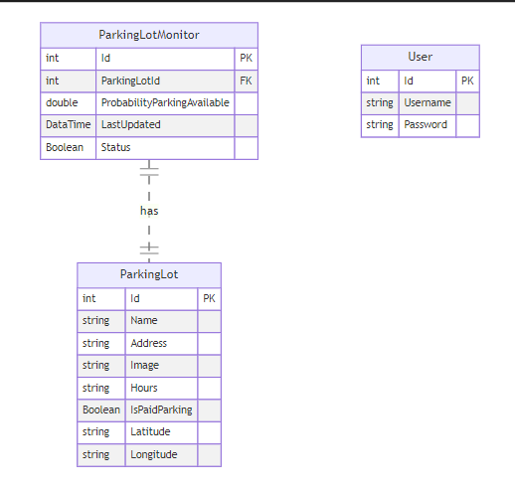

This database design consists of three tables: "User", "ParkingLotMonitor", and "ParkingLot".

* The "User" table has three columns: "Id" (Primary Key), "Username", and "Password".
* The "ParkingLotMonitor" table has six columns: "Id" (Primary Key), "ParkingLotId" (Foreign Key), "ProbabilityParkingAvailable", "LastUpdated", "Status", and "DataTime".
* The "ParkingLot" table has seven columns: "Id" (Primary Key), "Name", "Address", "Image", "Hours", "IsPaidParking", "Latitude", and "Longitude".

The diagrams shows a relationship between the "ParkingLotMonitor" and "ParkingLot" tables through the use of the "has" symbol. The "ParkingLotId" column in the "ParkingLotMonitor" table acts as a connection point, serving as a foreign key to link the two tables.

## User Parking Sequence diagram

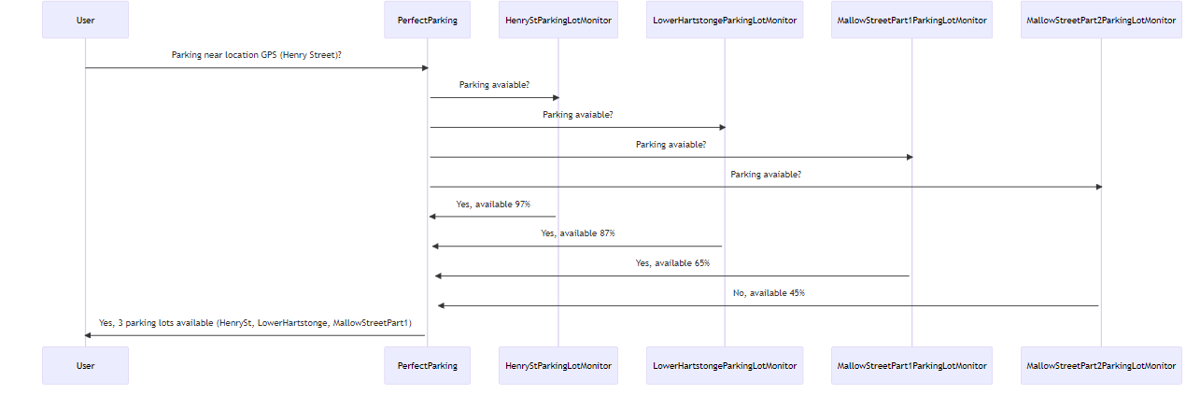

this is the sequence diagram of the process where a user is searching for parking near their location using the application. The user asks the app if there is parking available near their GPS location on Henry Street.

The app then queries multiple parking lot monitors, HenryStParkingLotMonitor, LowerHartstongeParkingLotMonitor, MallowStreetPart1ParkingLotMonitor, and MallowStreetPart2ParkingLotMonitor, to check if parking is available in each lot.

The HenryStParkingLotMonitor responds that parking is 97% available, the LowerHartstongeParkingLotMonitor responds 87%, MallowStreetPart1ParkingLotMonitor 65%, and MallowStreetPart2ParkingLotMonitor 45%.

Finally, the application then sends a response to the user indicating that there are 3 parking lots available near their location, with the names HenrySt, LowerHartstonge, and MallowStreetPart1.

# Prototype design for the pages

When I was thinking about how I would structure and layout my Perfect Parking web application I decided to draw up some diagrams to give me a better insight into what the pages would look like after the diagrams were hand drawn I was then able to make some HTML prototype pages so I can get a better vision into what they would look like in a web browser.

## Drawn prototypes.

### Login/Parking page



Above is my Login page, this page is where the users will be brought to when they first open the application. Once the users are logged in they will be brought to the parking page this is where they will see a list of all the parking spaces.

### View parking page



This is the view parking page, this page is opened when the user either searches or selects a parking lot from the parking page, here it will show information such as pictures of the car park, a map showing a pinned location of where the carpark is, this also allows you to get the direction to the parking lot by using google maps, you can also add this car park to your favourites and pay for your parking in advance if the user would like.

### Book Parking/Payment page



Once the user selects book parking, they will be brought to the booking page, here they can select the rate that they would like to park such as per hour or per day. Once the confirm parking button is pressed they will be brought to the payment page where they can input there card information to finish off the payment.

### View users/view user (Admin)



These two web application pages are for the admin, once the admin logs in they have the ability to view users and select a user, once the select a user has been selected the admin can do things such as suspend a user and edit user information.

## HTML Prototypes

### Login Page

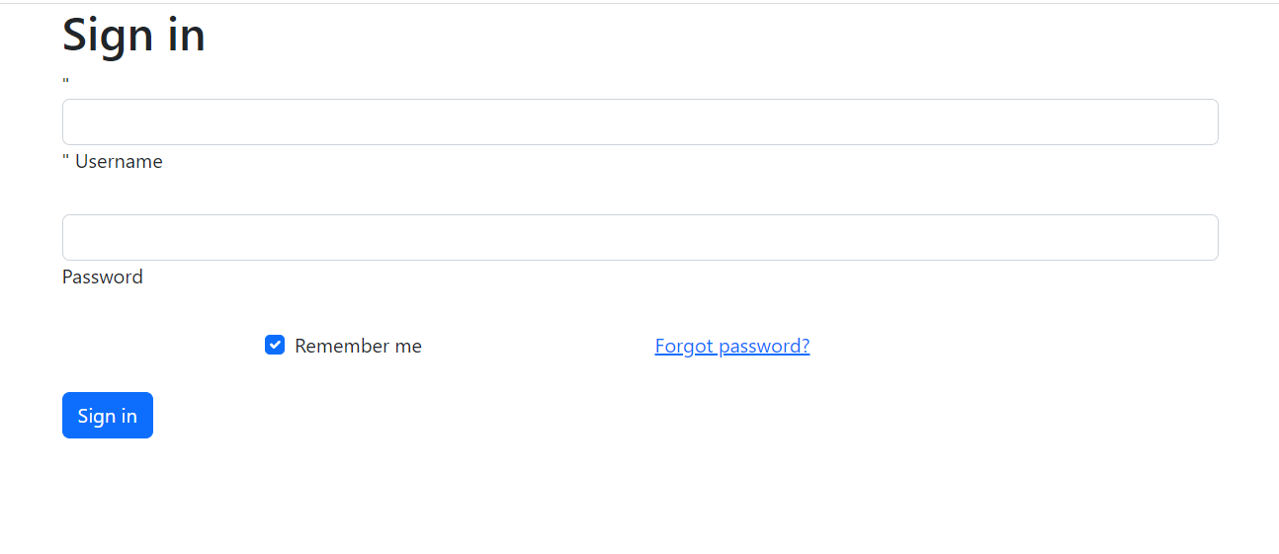

### Registration Page

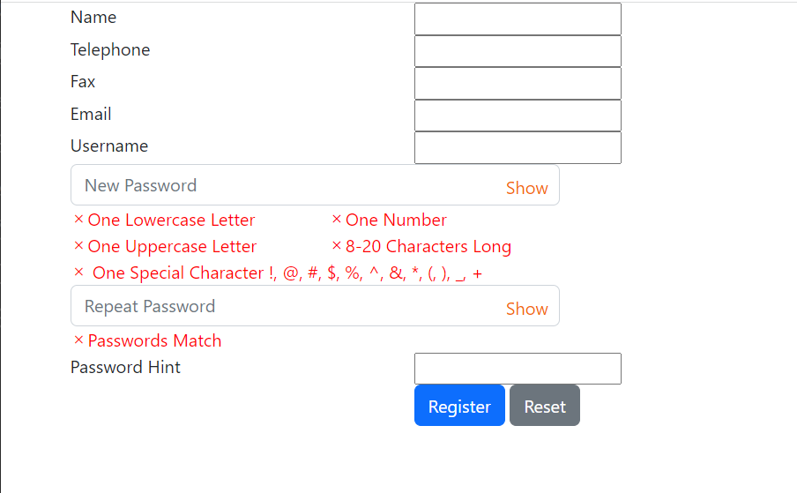

Implementation

Perfect Parking

Rhys Quilter: K00241356 | Software Develpoment | 19/01/2023

# Introduction

My Perfect Parking application was a project I designed to help people find parking lots and spaces in their area. I developed the application using programming languages such as Python and Java - along with key software such as Visual Studio Code.

Python is a powerful programming language that offers numerous advantages for implementing a successful parking application. Python is an open-source language, meaning developers can modify and share it freely, helping to reduce the cost, time, and effort of the development process.

## How i i will implement the open-Cv and make it possible to count the cars in the parking lot

1. Capture video feed from a camera or use a pre-recorded video.
2. Pre-process the video to remove noise and enhance the image.
3. Detect vehicles in the video using object detection techniques in OpenCV.
4. Track the vehicles as they enter and exit the parking lot.
5. Keep a count of the number of vehicles in the parking lot.
6. Display the count on the screen and alert the user if the parking lot is full.
7. Store the count data in a database for later analysis.

This is just a general outline, of how I will use openCv to count the number of cars in the parking lot.

# References

(n.d.). Retrieved from casrsoftware.com: https://www.castsoftware.com/glossary/Software-Architecture-definition-examples-explanation-tools-principle

(n.d.). Retrieved from TechVidvan: https://techvidvan.com/tutorials/why-big-data/

(2021, August 1st). Retrieved from splunk.com: https://www.splunk.com/en_us/data-insider/what-is-real-time-data.html

(2021, April 24th). Retrieved from geeksforgeeks.org: https://www.geeksforgeeks.org/why-we-should-use-asp-net/#:~:text=These%20applications%20have%20windows%20authentication,lot%20of%20strength%20and%20versatility.

(2022). Retrieved from UL.ie: https://www.ul.ie/presidents-office/university-profile/facts-and-figures

(2022). Retrieved from bankmycell.com: https://www.bankmycell.com/blog/how-many-phones-are-in-the-world

APCOA. (2022). *APCOA Parking*. Retrieved from APCOA.ie: https://www.apcoa.ie/location-search/Moylish,%20Limerick,%20Ireland

Ashish. (2022, july 8th). Retrieved from scienceabc.com: https://www.scienceabc.com/innovation/how-does-google-maps-know-about-traffic-conditions.html#:~:text=Google%20Traffic%20works%20by%20crowdsourcing,geographic%20location%20with%20the%20app.

Barnett, M. (2017, August 1st). Retrieved from fourthsource.com: https://www.fourthsource.com/data/importance-real-time-data-five-reasons-need-22014

Bashir, F. (n.d.). Retrieved from educative.io: https://www.educative.io/answers/what-are-java-spring-framework-advantages-and-disadvantages

Botelho, B. (n.d.). *Big Data*. Retrieved from techtarget.com: https://www.techtarget.com/searchdatamanagement/definition/big-data

George, M. (2021, january 21st). Retrieved from DZone.com: https://dzone.com/articles/a-case-study-on-spring-framework

*Google Maps Platform*. (n.d.). Retrieved from Directions API overview: https://developers.google.com/maps/documentation/directions/overview#:~:text=The%20Directions%20API%20is%20a,for%20Google%20Maps%20Web%20Services

Hawkins, M. (2020, june 23). *The History And Rise Of APIs*. Retrieved from forbes.com: https://www.forbes.com/sites/forbestechcouncil/2020/06/23/the-history-and-rise-of-apis/?sh=9957ddb45c28

Quellmalz, R. (2021, march 18). *6 surprising facts about parking you probably dont know*. Retrieved from SpotParking.com: https://www.spotparking.com.au/insights/facts-about-parking-you-probably-didnt-know

Simplilearn. (2022, Febuary 22nd). Retrieved from simplilearn.com: https://www.simplilearn.com/tutorials/spring-boot-tutorial/what-is-spring-framework-and-its-advantages

Tyler, C. (2022, october 29th). Retrieved from guru99.com: https://www.guru99.com/what-is-asp-dot-net.html

*What is a Mapping API*. (n.d.). Retrieved from PunNub.com: https://www.pubnub.com/learn/glossary/what-is-a-map-api/

*What is an API*. (2022). Retrieved from aws.amazon.com: https://aws.amazon.com/what-is/api/

Wiseley, M. (2018, november 27). Retrieved from wakefly.com: https://www.wakefly.com/blog/what-is-asp-net-and-why-should-i-use-it/